Standard Costing Project
Name
Institution
Date

Standard Costing Project
Answers to Required:
1). Total standard cost of materials= $11,400
Working:
total standard cost= standard cost material +standard cost labor +standard cost variable overhead
500*42= standard cost material +8,000+1,600
Therefore, standard cost material = 11,400 (21,000-9,600)

2). how many yards of materials required at standard per kit?= 1.84 yard per kit
Working:
direct material standard quantity= total standard cost÷standard cost for direct materil
direct material standard quantity= 21000÷11400
direct material standard quantity =1.842 yards per kit

3). material price variance?= $18,070 Unfavourable
Working:
MPV= (Actual Quantity*Actual Price)-(Actul Quantity*Standard Price)
MPV = (500*42.14)-(500*6)
MPV= 21,070-3,000
MPV=18,070 unfavourable

4). standard direct labor rate per hour?= 1.789
Working:
Standard direct labor rate= labor standard cost÷standard labor quantity
Standard labor rate = 4.697÷2.625
Standard labor rat=1.789

5). (a) Labor Rate Variance ?=$7844.90Unfavorable
Working;
LRV=(AH*AR)-(AH*SR)
LRV=(900*9455/900)-(900*1.789)
LRV=9455-1610.10
LRV=7844.90unfavourable
(b) Labor Efficiency Variance?= $1605.40Unfavorable
LEV=(AH*SR)-(SH*SR)
LEV= (900*1.789)-(2.625*1.789)
LEV= 1610.1-4.696
LEV=1605.40U
6). (a) Variable Overhead Spending Variance?= 746.25 Unfavorable
Working:
VOSV=(Actual Hour worked*Actual Overhead Rate)-(Actual Hour worked*Standard Rate)
VOSR=(900*1620/900)-(900-26.25)
VOSR=1620-873.75
VOSR=746.25 U
(b). Variable Overhead Efficiency Variance?= 1773.75Unfavorable
VOEV=(Actual Hours worked*Standard Overhead Rate)-(Standard Hour allowed*Standard Rate)
VOEV =(900*2)-( 13.125*2)
VOEV=1800-26.25
VOEV=1773.75U

Part 2: Cash Flow Statement
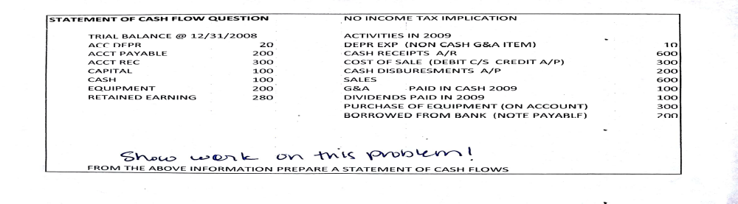
Mary Lynette Co.
Statement of Cash Flow
For the year ended December 31, 2009
- Cash Flow from Operating Activities Amount (in $) Amount (in $)

Account depreciation 20
Account payable (200)
Account receivable 300
Cash receipt 600
Cash disbursement (200)
G&A Cash Payment (100)
Net cash flow from Operating Activities 420

- Cash Flow from Investing Activities
Equipment (200)
Purchase of equipment (300)
Capital expenditure (100)
Net cash flow from Investing Activities (600)

- Cash Flow from Financing Activities
Dividend paid (100)
Note payable 200
Sales proceeds 600
Retained Earnings 280
Net cash flow from Financing Activities 980

Net increases in cash and cash equivalents 800
Cash and cash equivalent in the beginning of the year 100

Cash and Cash Equivalent at the End of the Year 900

